**PAS**

**To:** Dr. Matt Bohm

**From:** PAS

**Project:** Plasma Arc Speaker

**Subject:** Concept Variant 3

**Date:** March 4, 2011

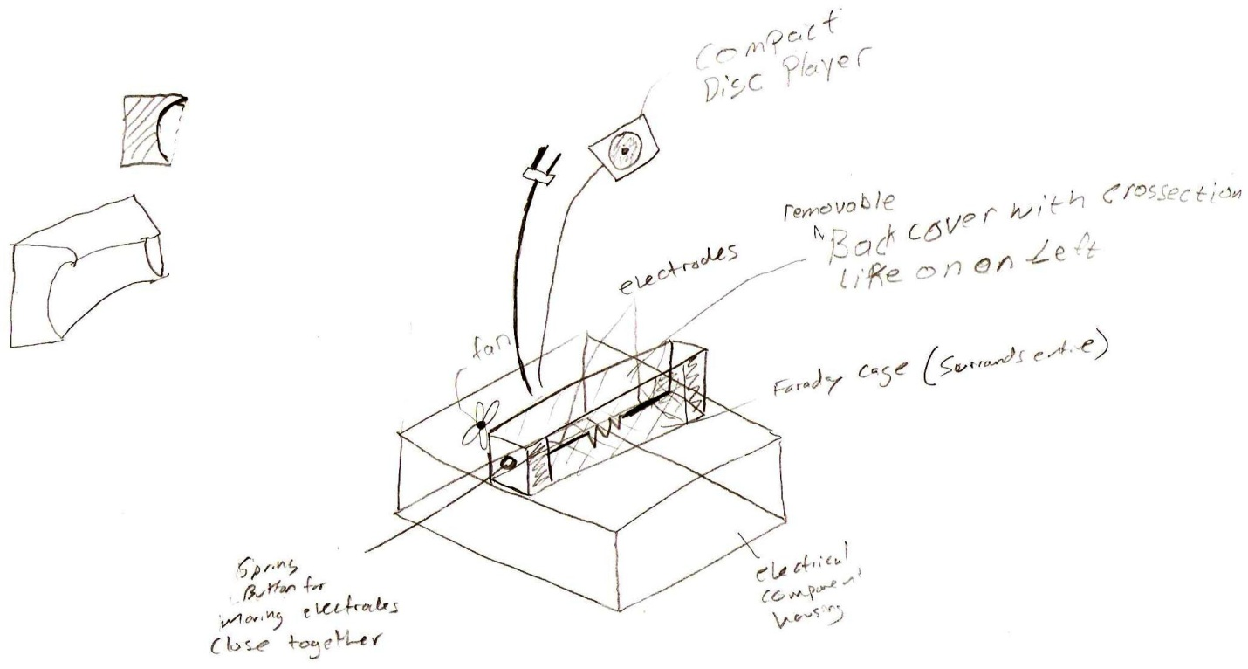

CV 3 consists of a housing on the bottom for electrical components with a fan in the back and a hinged door for easy access.  The electrodes are located horizontally above the housing and are insulated from on the left and right with wood or a ceramic material, and are surrounded by a Faraday cage.  The left electrode is connected to a spring, which has a button on the other end for moving the electrode. A conical back is located behind the speaker to allow for directional sound.